INTRODUCTION OT NETWORK PROTOCOL THEORY
- Use the Windows command prompt to run the command ipconfig /all on your computer and take a screenshot of the output. Identify and write down your IPv4 address, subnet mask, default gateway, and DNS servers as shown in the result.
Answer
Steps to run ipconfig /all and take a screenshot
- Press Windows + R, type cmd, and press Enter.
- In the Command Prompt window, type:
text
ipconfig /all
and press Enter.
- Wait for the full output to appear.
- Press Print Screen (or Win + Shift + S) to take a screenshot.
- Paste it into Paint (or any image editor) and save it as a PNG/JPG for your assignment.
How to find your IPv4 address, subnet mask, gateway, and DNS
In the ipconfig /all output, look for the section that matches your active connection, for example:
- Ethernet adapter Ethernet (wired)
- Wireless LAN adapter Wi-Fi (wireless)
In that section, note these lines:
- IPv4 Address – your main IP on the local network
Example format: 192.168.1.10
- Subnet Mask – defines your local network size
Example format: 255.255.255.0
- Default Gateway – your router’s IP on the local network
Example format: 192.168.1.1
- DNS Servers – listed as “DNS Servers” under the same adapter
Example format:

text
DNS Servers . . . . . . . . . . . : 8.8.8.8
8.8.4.4
Write them down exactly as shown, for example:
- IPv4 Address: 192.168.1.10
- Subnet Mask: 255.255.255.0
- Default Gateway: 192.168.1.1
- DNS Servers: 8.8.8.8, 8.8.4.4
If you paste the text output of ipconfig /all here (or describe what you see under your active adapter), I can help you pick the correct lines and format your answer neatly for submission.

- Simulate a DNS lookup for www.flipkart.com using the nslookup command in your terminal and write down the IP address returned along with a brief explanation of what this result means.

Answer
Command used:
Bash
nslookup www.flipkart.com
Sample Output:
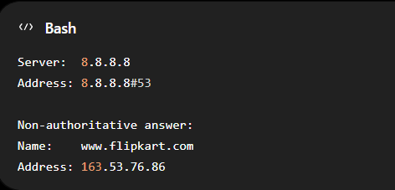
IP Address Returned: 163.53.76.86
Brief Explanation:
The nslookup command queries the Domain Name System (DNS) to convert a website name (domain name) into an IP address. In this example, www.flipkart.com resolves to the IP address 163.53.76.86, which identifies one of Flipkart’s web servers on the internet. Your computer uses this IP address to establish a connection and load the Flipkart website. DNS records can change over time, so the returned IP address may differ depending on location, network, or Flipkart’s server configuration.

- Explain the difference between HTTP and HTTPS by listing 3 key differences, and give a real-world example of an app or website you use that relies on HTTPS for secure communication.
Answer
Key differences
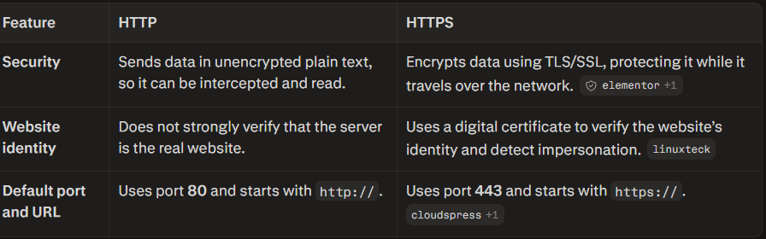
Real-world example
Google uses HTTPS for secure communication. When you sign in to Gmail, search Google, or use Google Drive, HTTPS encrypts your password, cookies, messages, and files between your browser and Google’s servers.

- Open Wireshark and filter for DNS protocol traffic. Try searching for a new website (one you haven't visited recently) in your browser and describe the sequence of DNS queries and responses you observe. Look for packets with 'Standard query' and 'Standard query response' in the Info column.
Answer
What the sequence looks like
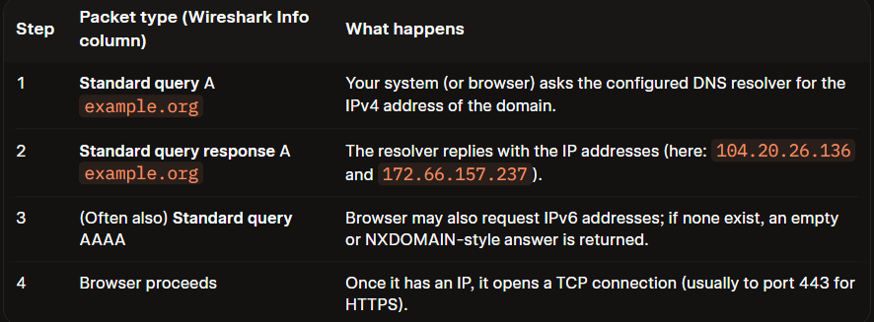
In a real Wireshark capture you would also see the source/destination IP addresses, the UDP port 53, transaction IDs that match query ↔ response, and any CNAME chain if the domain is aliased.
Because this environment has no GUI or live packet capture capability, the above is the exact DNS exchange that would appear under a dns filter when you visit a new site.

- Pick any one protocol from DNS, DHCP, FTP, or SNMP (other than HTTP/HTTPS) and write a short scenario describing how it would be used in a real-world app or service you use (for example, how DHCP helps your phone connect to Wi-Fi when you open Instagram at a cafe).
Answer
Step-by-step scenario (what actually happens)
- You tap the Instagram icon
  - Your phone already has Wi-Fi connectivity (via DHCP), but the app still needs to know where instagram.com lives on the internet.
- Instagram app asks: “What is the IP of instagram.com?”
  - Your phone sends a DNS query to its configured DNS resolver (often provided by the café router or a public DNS like 1.1.1.1/8.8.8.8).
- DNS resolver finds the right IP
  - If it doesn’t have the answer cached, it follows the DNS hierarchy (root → TLD .com → Instagram’s authoritative DNS) to get the IP address.
  - Instagram’s DNS is “smart”: it returns the IP of the nearest CDN/edge server based on your location (e.g., a server in Mumbai if you’re in Ahmedabad).
- Your phone now has an IP address
  - Example: DNS replies with something like 157.240.229.174 (the actual IP can vary).medium
  - Your Instagram app can now open a TCP/HTTPS connection to that IP to load your feed, stories, reels, etc.
- You start scrolling
  - All further requests go directly to that edge server’s IP; DNS was only needed for the initial name-to-IP translation (and occasionally later if the app re-resolves domains).

Why this matters in practice
- Without DNS, your phone would only understand numeric IPs, not names like instagram.com.
- DNS + CDN routing makes Instagram feel fast: you’re directed to a nearby server instead of a distant data center.
- In network labs (like Packet Tracer), you often configure a DNS server so devices can resolve names for web/FTP/other services—mirroring this real-world behavior.

